INTERVEST CONSTRUCTION, INC., a Florida corporation, Plaintiff-Appellant, versus CANTERBURY ESTATE HOMES, INC., a Florida corporation, Defendant-Appellee.

554 F.3d 914 (11th Cir. 2008)

Before BIRCH and DUBINA, Circuit Judges, and GOLDBERG, * Judge.

* Honorable Richard W. Goldberg, United States Court of International Trade Judge, sitting by designation.

BIRCH, Circuit Judge:
In this copyright infringement action the appellant contends that the district court erred when it examined the two floor-plans at issue, and, emphasizing the differences between the two, concluded "that, as a matter of law, no reasonable fact-finder could conclude" that appellant's floor-plan ("The Kensington") was substantially similar to appellee's floor-plan ("The Westminister"). More specifically, appellant ("Intervest") argues that the district court employed a "heightened 'substantial similarly' standard" by itself focusing upon certain dissimilarities between the two floor-plans at issue, based upon a misinterpretation of Howard v. Sterchi, 974 F.2d 1272 (11th Cir. 1992). For the reasons that follow we find no error and AFFIRM the judgment of the district court.

I. BACKGROUND
In point of time, the floor plan for The Westminster was created in 1992 as a work-made-for-hire by Intervest Construction, Inc. ("Intervest"). The putatively infringing floor-plan, The Kensington, was created in 2002 by Canterbury Estate Homes, Inc. ("Canterbury"). Each floor-plan depicts a four-bedroom house, with one bedroom being denominated as a "master" bedroom or suite. Each floor plan includes a: two-car garage; living room; dining room; "family" room; foyer; "master" bathroom; kitchen; second bathroom; nook; and porch/patio. Each floor-plan also reflects certain "elements" common to most houses: doors; windows; walls; bathroom fixtures (toilet, tub, shower, and sink); kitchen fixtures (sink, counter, refrigerator, stovetop, and pantry/cabinets); utility rooms and fixtures (washer, dryer, and sink); and closets. A cursory examination of the two floor-plans reveals that the square footage of both is approximately the same. Also, as is common to houses, there are placements of entrances, exits, hallways, openings, and utilities (furnace, air conditioner, hot water heater, and telephone hardware).
After identifying all of these unassigned components and elements of the floor-plans, the district court undertook a careful comparative analysis of the selection, coordination, and arrangement of these common components and elements. The district court focused upon the dissimilarities in such coordination and arrangement:

First, Canterbury represents that the square footage of the rooms in the two [*917] designs is different, and visual examination of the floor plans appears to confirm that. In any event, Intervest seemingly does not contest the point.
Second, the garage in The Westminster has a front entrance, while The Kensington's has a side entrance. Further, Intervest's design has an attic access from the garage, while Canterbury's version has a "bonus room" above the garage, something The Westminster lacks entirely. Moreover, the inside air conditioning unit and water heater are placed differently in the two floor plans. Additionally, The Kensington has two windows in the garage, while The Westminster has none. In The Westminster, there is a bedroom closet to the left of the utility room, whereas in The Kensington, there is a hallway in that location.
There are three bedrooms on the left side of the two designs, with a master bedroom across the house on the right side. (Confusingly, The Kensington drawing identifies the bedroom closest to the garage and the one farthest from the garage as "Bedroom 3.") There are significant differences between the left-side bedrooms in the two drawings.
The bedroom closest to the garage ("Bedroom 2" in The Westminster and one of two "Bedroom 3"'s in The Kensington) is shaped differently in the two designs. In The Westminster, this room's longest wall abuts the garage, whereas in The Kensington, a shorter wall separates the room from the garage. Additionally, in The Westminster, one would enter this particular room straight through a door at the end of a hallway, whereas in The Kensington, one would have to turn 90 degrees off the hallway to enter the room. Additionally, the entrance doors swing in opposite directions in the two designs. Moreover, the closets in this bedroom are situated on completely different walls in the two drawings.
Regarding the middle bedroom on the left side ("Bedroom 3" in The Westminster and "Bedroom 2" in The Kensington), the entrances and closets are different in the two floor plans. The closet in The Westminster runs nearly the length of one wall, while the closet in The Kensington is deeper, smaller, and occupies only a corner of the bedroom. The room in The Westminster has a 45 degree entrance, beyond which is an angled wall (followed by the aforementioned long closet). The Kensington's counterpart room has a 90 degree entrance which opens flush against a 90 degree wall. Finally, the bedroom in The Westminster appears more rectangular overall than its counterpart in The Kensington.
Moving to the last left-side bedroom ("Bedroom 4" in The Westminster and the other "Bedroom 3" in The Kensington), the same differences identified regarding the preceding bedroom also exist regarding this room, except that the smaller closet in The Kensington is located near the room's entrance, rather than in a corner.
The hallway bathroom situated next to this bedroom is also different in the two designs. The bathroom in The Westminster appears larger. Additionally, the alignment of the right wall vis-a-vis the hallway wall is different in the two plans. Further, "the bathtubs face opposite ways in the two designs," "the bathroom sink counter space in [The Kensington] is much smaller than in [The Westminster]," and "[The Kensington's] sink is oval shaped whereas [The Westminster's] is round." Doc. 50 at 16. Finally, although the bathroom door leading to the exterior of the house swings in the same direction in both [*918] plans, Canterbury notes that this is required by the fire code.
Proceeding to the center portion of the homes, the nooks in the two plans are markedly different. In that regard,

[The Westminster's] nook feeds into a ninety degree angle adjacent to the Porch and has windows looking both to the outside and to the Porch. On the other hand, [The Kensington's] design is rounded into the porch and is completely made of glass. There is no window to the outside or into the Covered Patio. Moreover, the entrance from the Nook into the Living Room in [The Westminster's] design has an elongated wall which travels much further into the Living Room than in [The Kensington's] design, and also fails to break inward at a ninety degree angle like in [The Kensington's] design.
Further, the shapes of the living rooms are different, in part due to the dissimilarities in the layout of the nooks.
The kitchens in the two plans are also substantially different. In that connection,

the wall placement in the southeast corner of the kitchens is significantly different. [The Kensington's] design pushes this wall further into the Living Room and pushes the Kitchen Counter much further north than in [The Westminster's] design. This allows [The Kensington's] design to have a much larger Pantry than [The Westminster's] design.
[Further, The Westminster's] design has a retractable door on its pantry which opens at a ninety degree angle while [The Kensington's] has a solid door which opens at a forty-five degree angle. Additionally, . . . [The Kensington's] kitchen counter is much thinner and longer than [The Westminster's] which places the dishwasher in a different location. Finally, . . . [The Kensington's] Kitchen has an Island as well as an entrance to a hallway running down the left side of the Utility Room while [The Westminster's] design has none of these features.
Moving to the right side of the house, there are material dissimilarities in the foyer, the master bedroom, and the master bath. The front entrance to The Westminster "has one solid door with windows on either side while [The Kensington's] front entrance has a pair of glass French Doors." Further, "the Master Bedroom in [The Kensington's] design contains glass French Doors on the far left side of the back wall which opens into a Covered Patio," whereas The Westminster "simply has a sliding glass door in the center of the back wall which opens to an uncovered Porch." Additionally, in The Kensington's master bath, "the doors to the walk-in closets . . . are solid and open in different directions than those [in the Westminster], which uses a retractable door." Finally, the sinks in the master bath are placed differently in the two designs. In The Kensington, the sinks are centered; in The Westminster, they are not.
Given the number of dissimilarities in the respective coordination and arrangement of these non-original, commonplace elements and components, the district court ruled that no reasonable observer could conclude that the copyrightable elements of the two floor-plans were substantially similar.

[*919] II. DISCUSSION
Since we are dealing with a specific type of copyrightable work, here an architectural work, we begin by examining the statutory definition of an "architectural work," to wit: "the design of a building as embodied in any tangible medium of expression, including a building, architectural plans or drawings. The work includes the overall form as well as the arrangement and composition of spaces and elements in the design, but does not include individual standard features." 17 U.S.C. §101 (2008). A review of the legislative history discloses that such "individual standard features" include "common windows, doors, and other staple building components." Including the phrase "the arrangement and composition of spaces and elements in the design" demonstrates Congress' appreciation that "creativity in architecture frequently takes the form of a selection, coordination, or arrangement of unprotectible elements into an original, protectible whole." Accordingly, while individual standard features and architectural elements classifiable as ideas or concepts are not themselves copyrightable, an architect's original combination or arrangement of such elements may be. Thus, the definition of an architectural work closely parallels that of a "compilation" under the statute, that is: "[A] work formed by the collection and assembling of preexisting materials or of data that are selected, coordinated, or arranged in such a way that the resulting work as a whole constitutes an original work of authorship." 17 U.S.C. §101. The Supreme Court in Feist Publications, Inc. v. Rural Telephone Services Co., 499 U.S. 340 (1991), and our court in BellSouth Adver. & Publ'g Corp. v. Donnelley Info. Publ'g, Inc., 999 F.2d 1436 (11th Cir. 1993) (en banc) and Oravec v. Sunny Isles Luxury Ventures, L.C., 527 F.3d 1218 (11th Cir. 2008), indicated that the compiler's choices as to selection coordination, or arrangement are the only portions of a compilation, or here, architectural work, that are even entitled to copyright protection. Accordingly, any similarity comparison of the works at issue here must be accomplished at the level of protected expression -- that is, the arrangement and coordination of those common elements ("selected" by the market place, i.e., rooms, windows, doors, and "other staple building components"). In undertaking such a comparison it should be recalled that the copyright protection in a compilation is "thin." Moreover, as the Second Circuit has noted, the substantial similarity inquiry is "narrowed" when dealing with a compilation. Key Publications, Inc. v. Chinatown Today Publ'g Enter., Inc., 945 F.2d 509, 514 (2d Cir. 1991).
Thus, when viewed through the narrow lens of compilation analysis only the original, and thus protected arrangement and coordination of spaces, elements and other staple building components should be compared. ³ We have recognized [*920] that summary judgment may be inappropriate in certain types of copyright infringement cases. However, we have approved the use of summary judgment particularly in cases where: (1) because access has been established, the crucial issue is substantial similarity; (2) there may be substantial similarity with respect to the non-copyrightable elements of the two works compared; and, (3) as to the protectable elements, there is substantial dissimilarity. In fact, when the crucial question in a dispute involving compilations is substantial similarity at the level of protectable expression, it is often more reliably and accurately resolved in a summary judgment proceeding. This is so because a judge is better able to separate original expression from the non-original elements of a work where the copying of the latter is not protectable and the copying of the former is protectable. The judge understands the concept of the idea/expression dichotomy and how it should be applied in the context of the works before him. As we have observed: "This distinction -- known as the idea/expression dichotomy -- can be difficult to apply, as there is no bright line separating the ideas conveyed by a work from the specific expression of those ideas." Moreover, in examining compilations wherein only the arrangement and coordination of elements which by the nature of the work (here architectural floor plans) are sure to be common to each of the works and are not copyrightable themselves (spacial depictions of rooms, doors, windows, walls, etc.), the already difficult tasks may become even more nuanced. Because a judge will more readily understand that all copying is not infringement, particularly in the context of works that are compilations, the "substantial-similarity" test is more often correctly administered by a judge rather than a jury -- even one provided proper instruction. The reason for this is plain -- the ability to separate protectable expression from non-protectable expression is, in reality, a question of law or, at the very least, a mixed question of law and fact. It is difficult for a juror, even properly instructed, to conclude, after looking at two works, that there is no infringement where, say, 90% of one is a copy of the other, but only 15% of the work is protectable expression that has not been copied. Part of the problem, which we have recognized, is that the term "substantial similarity" has not always been used with precision. When courts have dealt with copyright infringement claims involving creative types of works, "substantial similarity" has been defined as existing "where an average lay observer would recognize the alleged copy as having been appropriated from the copyrighted work." However, as noted above, while a creative work is entitled to the most protection, a compilation is entitled to the least, narrowest or "thinnest" protection. Accordingly, when courts have examined copyright infringement claims involving compilations the definition of "substantial similarity" has been appropriately modified to accentuate the narrower scope of protection available, to wit:

Not all copying constitutes infringement, however, and therefore we have emphasized that the substantial similarity analysis "must focus on similarity of expression, i.e., material susceptible of copyright protection."

Oravec, 527 F.3d at 1224 (emphasis in original) (involving a dispute over architectural plans).
Here the district court carefully compared the protectable aspects of the two floor-plans at issue, thus focusing only on the narrow arrangement and coordination of otherwise standard architectural features. At the conclusion of its analysis identifying many dissimilarities or differences in the two floor plans, the court made essentially the same ruling that we approved of in Oravec: "At the level of protected expression, the differences between the designs are so significant that no reasonable, properly instructed jury could find the works substantially similar."

III. CONCLUSION
Here the appellant, plaintiff below, contends that the district court erred in focusing its comparison of common architectural elements in two designs for a four-bedroom house on the dissimilarities between the two floor plans. Given that the plans at issue were protected by compilation copyrights which were "thin," the district court correctly determined that the differences in the protectable expression were so significant that, as a matter of law, no reasonable properly-instructed jury of lay observers could find the works substantially similar. Accordingly, the district court did not err in granting summary judgment to the appellee, the putative infringer.
AFFIRMED.

[Plaintiff’s floor plan:]
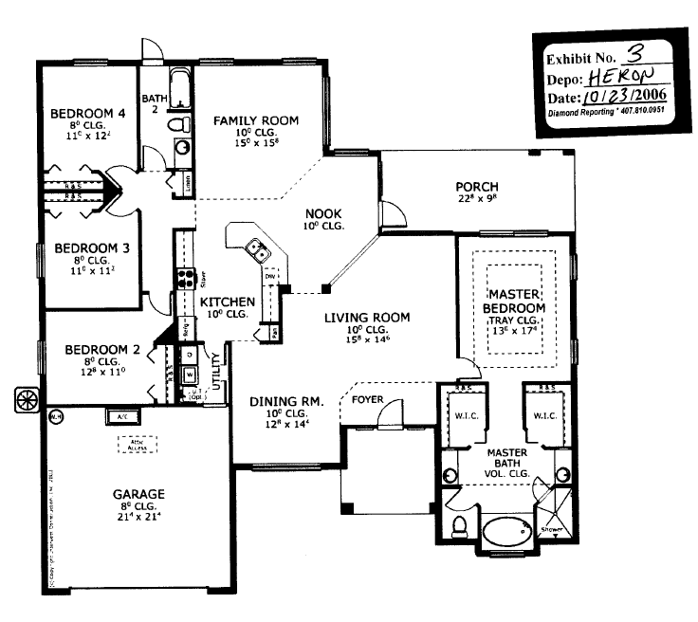

[Defendant’s floor plan:]
